PRICES EFFECTIVE JANUARY 1, 2006

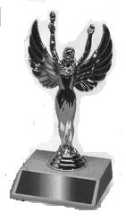  Trophy A  Victory Girl Figure  on 2 x 3 Marble Base  Price $1.85 | Trophy B  Beauty Queen Figure  On 2 x 3 Marble Base  Price $2.85  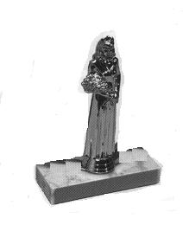
  Trophy C  Acrylic Fan-back Trophy With Victory Girl Figure on 1 Hole Marble Base  Price $ 5.00 | Trophy D  Acrylic Fan-back Trophy With Beauty Queen Figure on 1 Hole Marble Base  Price $ 6.00
Trophy E  Round Trophy Tubing  Marble Base,  Victory Girl Figure  without year trim date  8 inch $3.10  10 inch $3.35  12 inch $3.60  14 inch $4.10  16 inch $4.60  18 inch $5.10  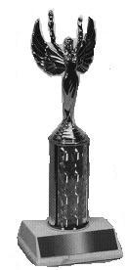 | 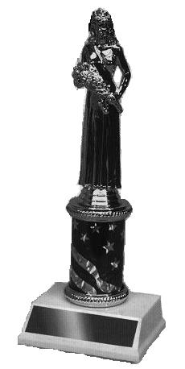  Trophy F  Round Trophy Tubing Marble Base, Beauty Queen Figure  without year trim  8 inch $4.10  10 inch $4.35  12 inch $4.60  14 inch $5.10  16 inch $5.60  18 inch $6.10

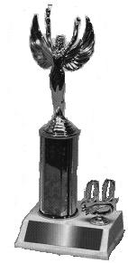  Trophy G  Round Trophy Tubing Marble Base, Victory Girl Figure with year trim date  8 inch $4.20  10 inch $4.45  12 inch $4.70  14 inch $5.20  16 inch $5.70  18 inch $6.20 | Trophy H  Round Trophy Tubing Marble Base, Beauty Queen Figure with year trim date  8 inch $5.20  10 inch $5.45  12 inch $5.70  14 inch $6.20  16 inch $6.70  18 inch $7.20  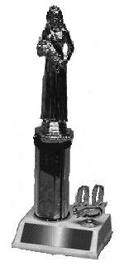
Trophy I  Round Trophy Tubing  Marble Base, Riser,  Victory Girl Figure  without year trim date  18 inch $7.30  20 inch $7.80  22 inch $8.30  24 inch $8.80  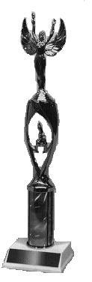 | 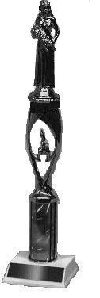  Trophy J  Round Trophy Tubing Marble Base, Riser,  Beauty Queen Figure without year trim date  18 inch $8.30  20 inch $8.80  22 inch $9.30  24 inch $9.80

Trophy K  Round Trophy Tubing  Marble Base, Riser,  Victory Girl Figure  with year trim date  18 inch $8.40  20 inch $8.90  22 inch $9.40  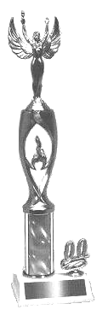  24 inch $9.90 | Trophy L  Round Trophy Tubing  Marble Base, Riser,  Beauty Queen Figure  with year trim date  18 inch $9.40  20 inch $9.90  22 inch $10.40  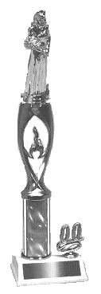  24 inch $10.90
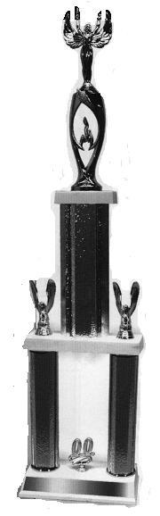  Trophy M  Double Column  Round Trophy Tubing,  20 & 05 on sides,  2 Post Marble Base Set,  Victory Girl Figure  24 inch $11.50  26 inch $12.00  28 inch $12.50  30 inch $13.00  32 inch $13.50  34 inch $14.00  36 inch $14.50 | Trophy N  Double Column  Round Trophy Tubing,  20 & 05 on sides,  2 Post Marble Base Set, Beauty Queen Figure  24 inch $12.50  26 inch $13.00  28 inch $13.50  30 inch $14.00  32 inch $14.50  34 inch $15.00  36 inch $15.50  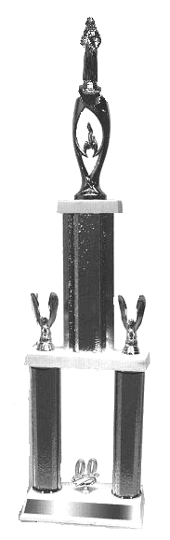

Trophy O  Triple Column  Round Trophy Tubing, Eagles on Sides, Triangular Wood Bases,  Victory Girl Figure  36 inch $26.00  48 inch $29.00  60 inch $34.00  72 inch $43.00  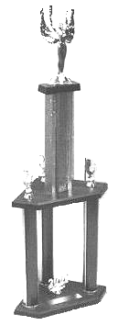 | 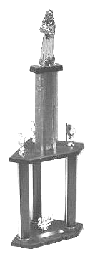  Trophy P  Triple Column  Round Trophy Tubing, Eagles on Sides,  Triangular Wood Bases, Beauty Queen Figure  36 inch $27.00  48 inch $30.00  60 inch $35.00  72 inch $44.00
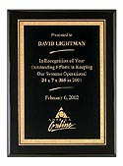
Plaque B
Wood Plaque,
Engraved Metal Plate
No Gold Plaque Relief

4 x6 $8.00
5 x 7 $9.50
8 x 10 $14.00

OTHER FIGURES AVAILABLE UPON REQUEST

WHEN ORDERING PLEASE SPECIFY A TUBING COLOR.

